EXPERIMENT-23
AIM
To analyze clinical trial data using hypothesis testing and calculate the p-value to check whether the new treatment is significantly more effective than the placebo, and visualize the results using matplotlib.
ALGORITHM
- Import NumPy, SciPy, and matplotlib.
- Create two datasets: control group and treatment group.
- Calculate the mean of both groups.
- Perform an independent t-test to get the p-value.
- Plot the group means using a bar graph and display the p-value.
- Print the results and end the program.
CODE
import numpy as np
from scipy import stats
import matplotlib.pyplot as plt

# ---------------------------
# Step 1: Sample clinical data
# ---------------------------
control = np.array([12, 15, 14, 16, 13, 15, 14, 17, 16, 15]) # Placebo group
treatment = np.array([18, 20, 19, 22, 21, 20, 23, 19, 21, 22]) # New drug group

# ---------------------------
# Step 2: Means
# ---------------------------
control_mean = np.mean(control)
treatment_mean = np.mean(treatment)

# ---------------------------
# Step 3: Hypothesis Testing
# ---------------------------
t_stat, p_value = stats.ttest_ind(treatment, control)

# ---------------------------
# Step 4: Visualization
# ---------------------------
groups = ["Control", "Treatment"]
means = [control_mean, treatment_mean]

plt.bar(groups, means)
plt.title(f"Treatment Effect Comparison\nP-value = {p_value:.4f}")
plt.xlabel("Group")
plt.ylabel("Mean Response")
plt.show()

# ---------------------------
# Step 5: Print Output
# ---------------------------
print("Control Group Mean:", round(control_mean, 2))
print("Treatment Group Mean:", round(treatment_mean, 2))
print("P-value:", p_value)
INPUT:
Sample clinical trial data used in the program:
Control Group:
12, 15, 14, 16, 13, 15, 14, 17, 16, 15
Treatment Group:
18, 20, 19, 22, 21, 20, 23, 19, 21, 22
OUTPUT:
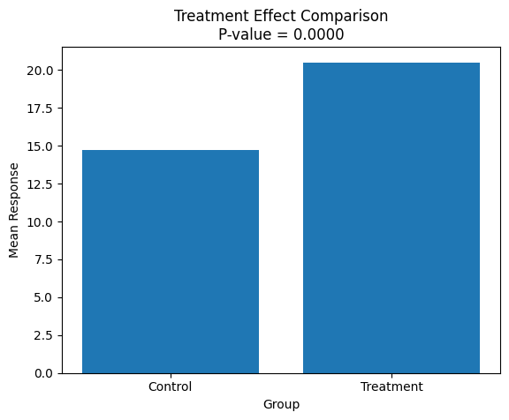
Control Group Mean: 14.7
Treatment Group Mean: 20.5
P-value: 1.1529123635561469e-07
RESULT:
The hypothesis test shows the p-value, and since it is very small, the treatment group has a statistically significant improvement compared to the control group. The graph confirms the difference visually.

